## Middlesex Community College - Center For New Media - Digital Media Production

## DGA 110

# Computer graphics

## Student Information Form

## Here is your first assignment.

## Please answer the following questions to the best of your ability.

## Once completed save it, and email the saved file to me at: [reriksen@mxcc.edu](mailto:reriksen@mxcc.edu)

1. Please enter the following contact information:

**Name: Matthew Quijano**

**School Email:** mquij0002@mail.ct.edu

**Secondary Contact Method (optional):**

2. Please describe the technology (computer/laptop/tablet) you will be using to access Blackboard, [office.com](http://office.com), and the assorted material presented in the class?

(include technical details if known…to the best of your ability…os, cpu, memory, storage size, microphone, webcam, etc.)  
Laptop:

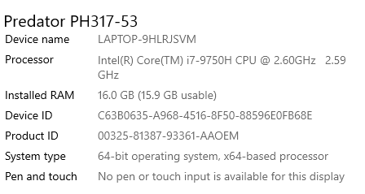

3. List and describe the range of digital software applications that you have had experience with prior to taking this class?

- Microsoft Office: Word, Powerpoint, Excel (Generally for school, but my high school mostly used their Google counterparts: Docs,Slides and Sheets)

- Adobe: Photoshop (Plentiful of experience. Wouldn’t say that I’m an expert, but I am able to perform some more complex actions within the program.), Premier (Basic video editing, nothing special)  
- Most likely irrelevant to this class: Visual Studio Code, IDLE and other programs related to coding.

4. Please describe what motivated you to take this course?

(you can be honest even if it’s as simple as it fulfills a requirement)

- I actually don’t know. It doesn’t seem to be listed as a requirement for the degree that I’m aiming for, but I wouldn’t mind taking it.

5. Ideally, what would you like to learn from this class and in what ways do you intend to apply what you learn going forward with your educational goals?

- I would like to learn how to be more capable of using the programs that we are using. However, I don’t know how I will be able to connect this class to either of my educational goals, being either web development or database administration. But it is always nice to have these skills at my disposal.

6. Throughout the course I will be holding casual open sessions via WebEx video conferencing (**again, optional**) for those students who have questions, would like further explanation of projects and in general just like to connect in “real time” for a bit.

I’ve set the first session for Wednesday, August 26th at 9:30am as the first open lab session time and understand this may not work for some of you who might want to participate (**remember, it’s optional**). Please list a few alternate days and times that might work for you….

This time works for me.